Q 1. What is cloud computing?

Ans- Cloud computing is on-demand delivering compute power, database, storage, application & Other IT resources through a cloud service platform via the internet with pay as you go pricing model.

Lets take one example for understand:-

I want to open company so what all thing I need

1 server

2 router & switches

3 Gateway & firewall

Above thing I have to purchase immediately to start my company so I have to invest 5-7 lakhs.

Then I need employees also for working & 24\*7 electricity cost.

So to start my company I need 10 lakhs rupees to overcome all these problem cloud come in picture.

For same thing if I take from cloud service then I can start my work within 50-60 thousands RS. & better Scalability , reliable process.

Lets take real time environment example

Amazon every day 10 lakhs user visiting on sites for buy something so Amazon using 4-5 server for this.

But when festival come then Amazon anounance 70% off this date so what happened you people also know. Suddenly visiting strength on website increase that day if only 4-5 server using then site response is slow or maybe crash. if Amazon buy new server then cost will increase so cloud provide facility you buy server for how many hours/day you need and pay for that time only.

Top Cloud company in markets

AWS , Microsoft Azure , Google colud, Alibaba cloud, Oracle cloud , IBM cloud & VMware

Characteristics of cloud

1. On demand self service
2. Broad network Acess
3. Scalability
4. Resource Pooling
5. Measured service

AWS launched in 2006 & 2010 new name Amazon.com

Certification launch in 2013 & 2015-2016 profit double.

Services in cloud

3 Types services provided

1. IAAS ( infrastructure as a service)
2. PAAS ( Platform as a service)
3. SAAS ( software as a service)

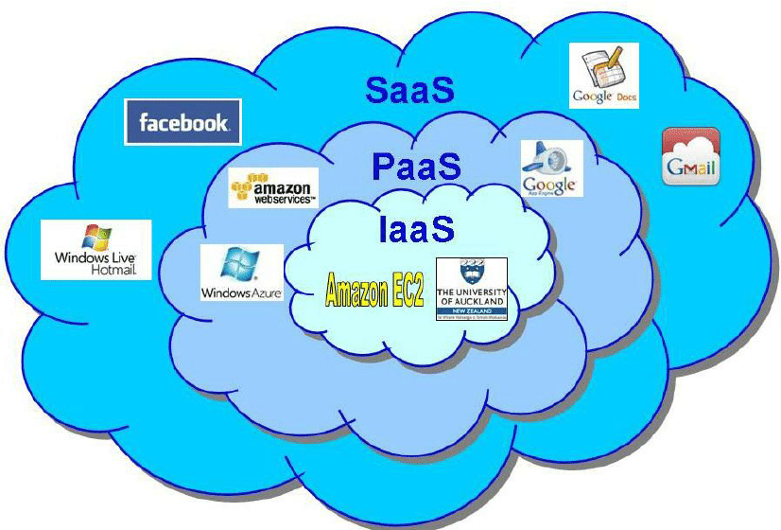

Deployment/Types of cloud

1. Public cloud- AWS , Azure , GCP
2. Private cloud or enterprise cloud
3. Hybrid cloud

